**P.3 LITERACY IA LESSON NOTES TERM II**

***Week I***

**LESSON 1**

**CONTENT: Living things**

Living things are things which have life.

# **Examples of living things**

* plants - man
* birds - dogs
* fish - giraffes
* insects

# **Characteristics of living things**

* All living things feed
* All living things move
* All living things respire
* All living things grow
* They all reproduce
* They respond to stimuli

**Groups of living things**

* animals
* plants

# **Mixed activity**

1. What are living things?
2. Identify any four examples of living things
3. Why are plants called living things?
4. State any four characteristics of living things
5. A part form plants, name any other group of living things

**LESSON 2**

**CONTENT:** **Uses of animals**

* Some animals are eaten by people e.g. cows, goats, sheep, camel etc.
* Some animals are sold to get money.
* Cats eat rats and mice in our homes
* Some animals provide skin and hides e.g. cows, goats, sheep, camels etc.
* Some animals are used for transport e.g. donkey, horses, camels.
* Dogs provide security at home - Sheep provide us with wool and mutton.
* Animal dung is used to make manure.
* Oxen are used for ploughing

# **Examples of animal products**

* skins - wool
* dung - fur
* urine - milk
* blood - meat

# **Things made from skin and hides**

* Drums - Bags - Shoes
* Bag wallets - Belts

# **Exercise**

1. Mention any three things made out of wool.
2. Why do we keep cats at home?
3. Identify the domestic animal kept for security.
4. Give any two aquatic animals
5. Give the habitats of following animals

Lion __________ squirrels __________ zebra __________

2

**LESSON 3**

**CONTENT:** ***Caring for animals***

* Feeding them
* Building shelter for animals
* Treating animals
* Putting wild animals in game parks.
* Spraying with chemicals.
* Avoid destroying swamps and forests.

# **Birds and insects**

**Characteristics of birds**

- Birds lay eggs.

* Birds’ bodies are covered with feathers,
* Birds have wings
* They have beaks

# **Exercise**

1. How useful are feathers to birds?
2. How do the following animals move?

Frogs ___________

Fish ____________

Snakes ____________

1. What do birds use to breathe?
2. Identify any three ways how people can care for animals
3. In one sentence give the meaning of animal habitat.

**LESSON 4**

**CONTENT: Types of birds**

- Domestic birds

* Wild birds

**Domestic birds**

* Domestic birds are birds tamed by people.

# **Examples of domestic birds**

|  |  |
| --- | --- |
| * Turkeys - * Pigeons - * Chicken -   **Wild birds**  Wild birds are birds that live in the bush or forest.  **Examples of wild birds** | Ducks  Guinea fowls  Parrots |
| * Crested crane - * Crows - * Ostrich - * Vultures - * Weaver birds | sun birds eagles kites  penguin, kiwi, ostrich }  flightless birds |

- Marabou stork

**Exercise**

1. What is the difference between wild birds and domestic birds?
2. Why do people in your community keep birds like hens?
3. State any four examples of domestic birds
4. What are wild animals?
5. Identify any four examples of wild birds

**Week 2**

**LESSON 1**

**CONTENT: Habitats of birds**

* A habitat is a home of a living thing.
* Habitat of birds are homes of birds

**Examples of habitats for birds**

* Domestic birds live in cages while wild birds live in nests.

# **Common places where birds are found**

* swamps - gardens
* sanctuaries
* water
* forests

# **Uses of birds**

* Birds provide meat e.g. turkey, chicken, doves etc.
* Feathers are used for decoration e.g in suits, hats.
* Birds’ bones are used for making glue.
* Birds are sold to get money.
* Some birds are used for paying bride price
* Birds provide us with eggs

**Uses of feathers**

* For decoration
* For making pillows

# **Exercise**

1. State one use of birds to plants
2. Name three birds eaten by people.
3. How useful are birds to people?
4. How are feathers useful to people?
5. How can a P.3 boy protect water sources?

**LESSON 2**

**CONTENT: Caring for birds**

Providing shelter

* Feeding birds
* Cleaning their habitats
* Treating birds

**INSECTS**

# **Examples of insects**

|  |  |
| --- | --- |
| * White ants * Black ants * Tsetse flies * Wasps * Houseflies * Termites | * Mosquitoes * Bees * Locusts * Butterflies * Cockroaches |

**Parts of an insect**

A

B

C

D

E

I

F

G

H

1. Feelers
2. Compound eyes
3. Legs
4. Thorax
5. Wings
6. Spiracles
7. Ovipositor
8. Halteres

# **Uses of parts of an insect**

***Feelers*** - used for feeling

***Spiracles*** - used for breathing

***Wings***  - used for flying

***Ovipositors***  - used for laying eggs.

* Used for mating
* Used for protection in bees and wasps

- **Halteres** - For balancing when flying

# **Exercise**

1. Write two examples of insects
2. Draw an insect and name the

a) Spiracles - ovipositor

3. On which part of an insect are the legs attached?

1. How are the halters useful on an insect?
2. Why should we brush our teeth after every meal?
3. In one sentence give the meaning of soil profile.

**LESSON 3**

**CONTENT: Characteristics of insects**

An insect has three main body divisions i.e. head, thorax, abdomen.

* An insect uses spiracles for breathing.
* An insect has three pairs of legs or six legs.

# **Reproduction of insects**

# Insects reproduce by laying eggs Harmful insects

|  |  |  |  |  |
| --- | --- | --- | --- | --- |
| * Bees * Mosquitoes * Wasps * Termites * Black ants   **Useful insects**   * White ants * Grasshopper * Bees   **Insects which have wings** |  | -  -  - | Tsetse flies  Butterflies  Moths houseflies |  |
| * locusts * cockroaches * butterflies   **Insects without wings** |  | - - - | Bees  Houseflies  crickets |  |
| - Termites | - | Black ants | - | Red ants |

# **Qn: Why is a spider not grouped under insects**

* It has two main body divisions i.e. cephalo thorax and abdomen while an insect has three main body divisions.
* It has eight legs while an insect has six legs
* It uses book lungs for breathing while an insect uses spiracles for breathing.

# **Exercise**

1. Write two examples of insects which sting.
2. How many legs has an insect?
3. Give any two characteristics of insects.
4. Why is a spider not called an insect?
5. Name any four insects with wings
6. How do insects reproduce?

**LESSON 4**

**CONTENT: Types of insects**

* Social insects
* Solitary insects

**Social insects**

These are insects which move, live and work together.

# **Examples of social insects**

|  |  |
| --- | --- |
| * Honey bees * Black ants * Wasps * Termites | * Red ants or safari ants * sugar ants * soldier ants |

# **Characteristics of social insects**

* They live together with others
* They move together with others
* They work together with others

**Solitary insects**

Solitary insects are insects which live, move and work alone.

# **Examples of solitary insects**

|  |  |
| --- | --- |
| * Mosquitoes * Tsetse flies * Butter flies * Fleas | * Grasshoppers * Houseflies * Crickets * Bed bugs |

- Cockroaches

# **Characteristics of solitary insects**

* They live alone
* They work alone
* They move alone

# **Exercise**

1. Why is a spider not called an insect?
2. Give two characteristics of solitary insects.
3. What is the difference between social and solitary insects?
4. State any four examples of solitary insects

**LESSON 5**

**CONTENT: Uses of insect**

* Some insects are eaten as food e.g. white ants, grasshoppers and locusts.
* Bees provide us with honey and wax.
* Some insects pollinate crops e.g. bees, moths and butterflies

**Uses of honey**

- Honey sweetens bread.

* Honey is used as food.
* Honey is used as medicine

# **Things made out of bee wax**

|  |  |
| --- | --- |
| - Candle wax - Cosmetics | * Shoe Polish * Match sticks |

# **Dangers of insects**

* Many insects spread diseases e.g. house flies, mosquitoes, tsetse flies.
* Some insects destroy crops e.g. termites, grasshoppers and locusts.
* Some insects destroy furniture and house hold property e.g. cockroaches, wood lice - Some insects destroy animal habitats e.g. red ants, black ants

# **Exercise**

1. Write two insects eaten by people 2. Identify two products got from bees.

1. How does a wasp protect itself?
2. How is honey useful to people?
3. Identify any two products got from bee wax
4. State any two dangers of insects to people

**WEEK 5**

**LESSON**

**CONTENT: Insect habitat**

- Insect habitats are homes of insects

# **Examples of insect habitats**

* Anti hills - Leaves
* Water - Hives

# **Insect which live in (anti- hills)**

* White ants
* Termites

# **insects which live on leaves**

Butterflies

Tsetse flies

Mosquitoes

Hives

Bees

# ***NB:***

# **Examples of bees**

* **Queen bees**  - female bees in the hive

- They lay eggs

* **Worker bees**

– female sterile bees in the hive

– Collect nectar

* Clean the hive
* Feed the queen bee
* Protect the hive
* **Drone bees** – male bees in the hive

– mates with the queen bee

# **Exercise**

1. What are insect habitats?
2. Name any three-insect habitat
3. Identify any two insects which live on leaves
4. State any two types of bees
5. Underline the odd man out

Locust, termite, fleas, wasps, floods, thunder, brick making, lightning.

**LESSON 2**

**CONTENT: Parts of a fish**

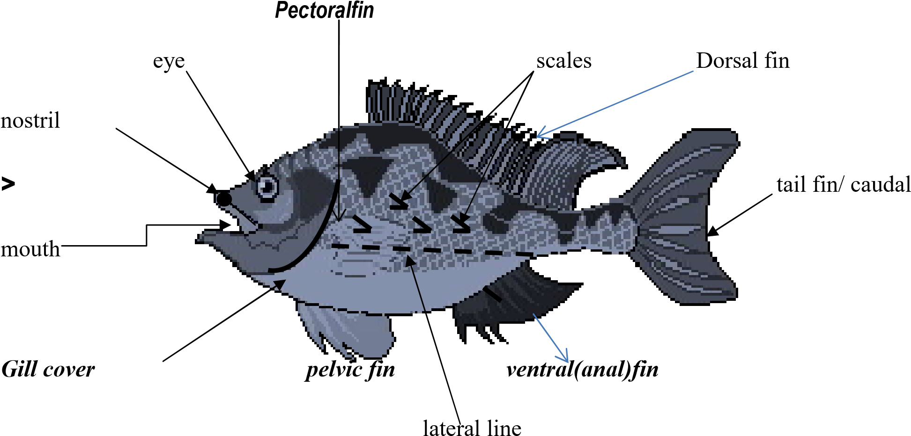

**Mouth:** For picking in food and water

**Nostril:** For tasting food

▪ For smelling food **Eye:** for seeing

**Gill cover:** protects gills

**Gills:** for breathing

**Lateral line:** for sensing sound waves in water

**Tail fin:** for moving forward and changing direction

**Dorsal:** - For protection.

-For rolling in water

**Ventral fins:** - For protection.

**Pectoral fin -** For stopping movement

**Pelvic fins:** For upward movement in water

**Scales** – protects the body from injury.

# **Exercise**

1. Which part of a fish is used for swimming backwards?
2. What is the function of gills to a fish?
3. How do we call a glass container used to keep fish and other aquatic animals.

**LESSON 3**

**CONTENT: Characteristics of fish**

* Fish use gills for breathing
* Fish produce by laying eggs.
* They have fins

# **Uses of fish to man**

* Fish is used as food by man (source of protein) - Bones of fish are used for making glue.
* Fish is sold to get money.
* Fish control malaria by eating mosquito larvae in ponds

# **Examples of common fish**

|  |  |
| --- | --- |
| * silver cyprinid * mud fish * tilapia | * cat fish * Nile perch * lung fish |

- salmon

# **Mixed activity**

1. How do fish reproduce?
2. Name any one common type of fish caught in your community.
3. Which food value do we get from eating fish?
4. Identify any four examples of fish caught in Uganda
5. How is fish useful to people?
6. Draw one item used to clean our body.

**LESSON 4**

**CONTENT: Fish habitat**

* Fish live in water
* We can keep fish in ponds and aquariums.

**NB:** A pond is a man-made pool of water.

An aquarium is a glass container where fish and other aquatic animals are kept

# **Examples of animals found in ponds**

|  |  |
| --- | --- |
| * fish * frogs | * crocodile * turtles |

- crabs

NB: A young fish is called a fry

# **Care for fish**

* Provide food for fish
* Protect their eggs from animals and birds

- Feeding the fries in pond.

* Cleaning water sources by removing water weeds and hyacinth

# **Exercise**

1. What name is given to young fish?
2. Give the meaning of the word “pond”
3. How can we care for fish?
4. State any three examples of animals found in ponds

Living things (animals) Word bank

stimuli flightless divisions reproduce habitat medicine manure sanctuaries cosmetics chemicals ovipositor spread tamed antenna diseases

|  |  |  |
| --- | --- | --- |
| sterite nostril nectar injury        **LESSON 5**  **CONTENT: Examples of plants** |  | aquatic aquarium |
| * maize plant * bean plant * rice plant * mosses plant   **Groups of plants**   * Non – flowering plants * Flowering plants   **Non – flowering plants**  These are plants which do not bear flowers  **Examples of non – flowering plants** | - - - - | sugar plant eggplant ferns lichens |
| - algae | - | ferns |

-liver Worts

- pines

-mosses - cedar - soft wood trees**/**conifers

-lichens - cypress

**NB:** They reproduce by means of spores

Conifers reproduce by means of seeds

# **Exercise**

1. Mention any two examples of plants you know.
2. What are non – flowering plants?
3. How do most non – flowering plants reproduce?
4. state one importance of conifers to people
5. How do conifers reproduce?

**WEEK 4**

**LESSON 1**

**CONTENT: Flowering plants**

* Flowering plants are plants that bear flowers NB: They reproduce by means of seeds.
* Root cap protects the growing tip of a root from damage. - Root hairs absorb water and mineral salts form the soil.

# **Examples of flowering plants**

|  |  |
| --- | --- |
| * bean plant * ground nut plant * mango plant * coconut plant | * maize plant * rice plant * coffee plant * orange plant |

**Parts of a flowering plant**

**Characteristics of plants**

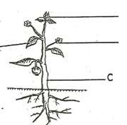

Fl

stem

Leaf

fruit

roots

ower

1. Make their own food.
2. Have chlorophyll

**LESSON 2**

**CONTENT: LEAVES**

Leaves grow from stems of a plant

* Leaves are supported by a leaf stalk on a plant

**Parts of a leaf**

stomata

Midrib

Apex

leaf margin

veins

Note:



leaf

base

leaf stalk

Lamina / leaf blade

stomata: Many stoma - one

# **Uses of each part of a leaf**

**Stomata:** used for breathing

**Leaf stalk:**  Holds a leaf on a plant stem

**Vein:** Transports water and mineral salts in all parts of a leaf.

**Midrib:** Transports water and mineral salts from the stem to the veins.

# **Exercise**

1. How important are stomata to a plant?
2. Name the green colouring pigment found in plants

3. State the use of the above-mentioned pigment to plants

1. Give one main use of leaves to plants.
2. Write down three uses of leaves to people

**LESSON 3**

**CONTENT: Uses of leaves to people**

* Many leaves are eaten as food e.g. cabbages, lettuce, pig weeds (dodo), spinach.
* Some leaves are used as herbal medicine e.g. Mululuza – malaria.
* Some leaves are used for thatching houses e.g. spear grass and papyrus Uses of **leaves to plants**
* Leaves make food for plants (main use)
* Some leaves store food for plants e.g. Lettuce, cabbage, sukuma wiki.
* Leaves have stomata used for breathing

- Leaves carry out transpiration.

NB: The main use of leaves to plants is to make food for plants.

**LESSON 4**

**CONTENT: PHOTOSYNTHESIS**

* Photosynthesis is a process by which plants make their own food.
* Photo – light
* Synthesis –manufacture

# **Raw materials for photosynthesis**

Carbon dioxide

-Water They are used as raw materials

# **Conditions for photosynthesis**

**Chlorophyll** – for trapping sunlight

**Sun light energy** – provide heat energy

# **Product of photosynthesis**

* Starch (food)
* Oxygen (waste product **/** by product)

**Gas given out by plants at night**

Carbon dioxide

**Gas taken in by plants at night**

* Oxygen

**Food made during photosynthesis**

* Starch

# Exercise

**WEEK 5**

**LESSON 1**

**CONTENT: STEMS**

Types of stems

* Upright stems
* Underground stems (storage stems)
* Climbing stems
* Creeping stem/ runners

# Examples of plants that store food in stems

* White yams
* Irish potatoes

# **Uses of stems to plants**

* Stems transport water and mineral salts from roots to leaves.
* Some stems store food for plants e.g. Irish potatoes, white yams.(stem tubers) - Stems transport food made by leaves to roots.

# **Uses of stems to people**

* Some stems are used as food e.g. sugar canes.
* Some stems are used as local medicine.
* Some stems are used as fire wood.
* Hard woody stems are used as timber.
* Soft woody stems are used for making ply wood and paper.
* Some stems are used for building houses.

**LESSON 4**

**CONTENT: ROOTS**

* A root is part of a plant which grow in the soil.

# **Types of root system**

* Tap root system
* Fibrous root system

**Tap root system**

Tap root system is the system of roots with the main root growing.

# **Parts of a tap root system**

**NB: Examples of plants with tap roots**



* Beans
* Mangoes
* Soya beans
* Jack fruits

# **Fibrous roots**

Fibrous root system is where many roots grow of almost the same size grow without the main roots.

Parts of a fibrous root system

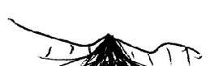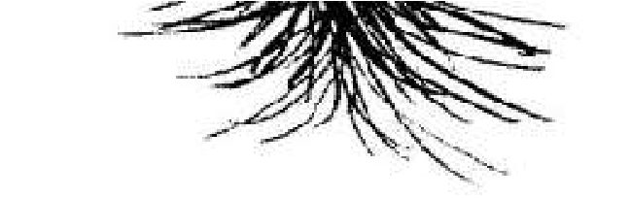

# **Examples of plants with fibrous roots**

* maize
* sorghum
* sugar cane
* millet
* rice

Exercise

**LESSON 3**

**CONTENT: Uses of roots to plants**

* Roots hold plants firmly in the soil.
* Roots absorb water and mineral salts from the soil.
* Some roots store food for plants e.g. cassava, sweet potatoes, carrots.

**Uses of roots to people**

* Some roots are eaten as food e.g. cassava, sweet potatoes, carrots.
* Some roots are used as local medicine
* - Some roots are used as firewood.

# **Examples of plants whose roots are eaten /root tubers**

* Cassava plants
* Sweet potatoes plants
* Carrot plants
* Root turnips

# Exercise

**LESSON 4**

**CONTENT: FLOWERS**

A flower is a reproductive part of a plant **Parts of a flower**

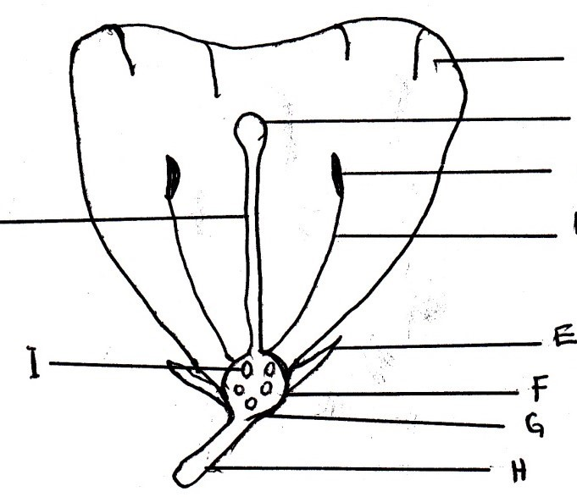

Petals

Stigma

Anther head

Style

filament

Ovules

Sepal

Receptacles

ovary

Flower stalk

Note: A group of petals is called corolla

* A group of sepals is called calyx
* A female part of a flower is called pistil
* A male part of a flower is called a stamen

**Parts of a pistil** **parts of a stamen**

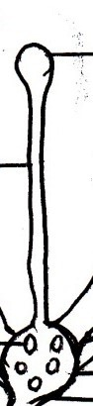

Style

Ovary

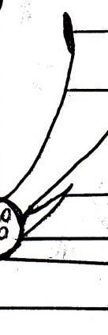

Stigma

Exercise

**LESSON 5**

**CONTENT: Uses of parts of a flower**

**Petals** – protects the inner parts of a flower

**Sepals** – to protect the flower when it is still in a bud stage.

**Ovules** – develop into seeds after fertilization

**Ovary** – protects ovules

**Anther** – to produce and store pollen grains

**Stigma** – receives pollen grains

**Style** – Holds the stigma upright

**Filament** – holds anthers in position

**Flower stalk** – holds a flower in a right position

**NB: Why insects visit flowers**

To get nectar (main reason)

To get pollen

To get water

# **Insects that visit flowers**

* Bees
* Butterfly
* moth (at night)

# **Exercise**

1. How useful are the following parts to a flower?

Ovary _____________

Anther ______________

Stigma _____________

1. State one use of flowers to people.
2. Why should we wash hands with soap after visiting latrines?
3. Why do bees visit flowers?

**WEEK 6**

**LESSON 1**

**CONTENT: Uses of flowers to people**

* Flowers are given as gifts
* Flowers are given to people to show respect and welcome
* Flowers are used for decoration
* Some flowers are eaten as food e.g. cauliflower, pumpkin flowers.
* Some flowers are used for making perfumes
* Flowers are sold to get money

**Uses of flowers to plants**

* Flowers are used for reproduction

# **Mixed activity**

1. How useful are flowers to people?
2. List any two functions where flowers are used for decorations.

**LESSON 2**

**CONTENT: CROP GROWING PRACTICES**

* Clearing land
* Planting
* Weeding
* Mulching
* Thinning
* Pruning

# **Clearing land**

Through

* Slashing using a slasher
* Ploughing using oxen
* Gathering using a rake, hoe and pick axe
* Digging up soil
* Leveling the soil
* Burning of the rubbish/ bush

# **Planting**

It involves selecting seeds and transplanting.

Transplanting is the transfer of seedlings from the nursery bed to the well prepared garden.

# **Methods of planting crops**

1. Row planting - (planting in lines)
2. Broadcasting – (scattering seeds using hands) e.g millet, sorghum

# **Caring for crops**

* Weeding - Mulching
* - Spraying with chemicals
* Pruning - Stalking
* Thinning - Watering

# **Exercise**

1. How can a farmer care for his maize in the garden?
2. Mention one activity carried out during land preparation
3. What is a nursery bed?
4. Mention at least two methods of planting 3crops.

**LESSON 3**

**CONTENT: Types of crops**

* Vegetable crops
* Cereal crops
* Legumes
* tuber crops
* Fruit crops

**Vegetable crops**

e.g. cabbages, pig weed, onions, lettuce, spinach

# **Cereal crops**

These are crops which produce grains e.g. (grains are seeds which provide flour) e.g. millet, maize, sorghum, wheat, barley, rice

# **Legumes**

These are crops whose roots have nodules e.g. beans, ground nuts, soya beans, green peas, cow peas, Bambara nuts.

**Fruit crops**

These are crops that provide fruits e.g. oranges, pineapples, passion fruits, mangoes

# **Tuber crops**

These are crops that store food in their underground parts e.g. cassava, sweet potatoes, white yams carrots and inch.

**Tuber crops**

1. Stem tubers e.g irish potatoes, white yams
2. Root tubers eg cassava, sweet potatoes, carrots Exercise

**LESSON 4**

**CONTENT: Garden tools and their uses**

|  |  |  |  |
| --- | --- | --- | --- |
| Name | Diagram | Use | |
| Trowel |  | - For transplanting seedlings | |
| Panga |  | - For cutting down small trees | |
| Watering can |  | - For watering crops | |
| Hoe |  | * For digging * For weeding | |
| Spade |  | * Removing manure * Removing loose soil | |
| Slasher |  | * For slashing * For cleaning land before digging | |
| Axe |  | - Cutting big trees | |
| Knapsack sprayer |  | - | For spraying |
| Secateur |  | - | For pruning |

**LESSON 5**

**CONTENT: Caring for garden tools**

* Keep garden tools in a cool dry place.
* Cleaning garden tools after using
* Sharpen garden tools used for cutting
* Paint metallic tools to avoid rusting

**Reasons for caring for garden tools**

- To prevent metallic tools from rusting

- To keep tools for a long time.

# **Prevention of garden tools from rusting**

* By oiling
* By painting
* By keeping metals in a clean dry place
* By cleaning and drying them after use

# Exercise

**WEEK 7**

**LESSON 1**

**CONTENT: CROP PESTS**

Crop pests are organisms which destroy crops

# **Examples of crop pests**

* rats
* locusts
* caterpillars
* crickets

- monkeys - moles

-termites - squirrels

-weaver birds - birds

-been weevils

**Dangers of crop pests**

* They eat up plant leaves
* Destroying of fruits
* Pests lead to low yields

# **How to control pests and diseases**

* Spraying with pesticides
* By weeding
* Trapping pests
* Using scare crows
* Cats can be used to control pests like rats in granary
* Uproot and burn infected crops
* Practice crop rotation
* by chasing the pests

# **Signs of pest damage on crop**

* Holes on leaves
* Yellowish leaves
* Holes in fruits
* Wilting of crops, drying of the crops

Exercise

**Word bank**

|  |  |  |
| --- | --- | --- |
| bear spores stomata oloevera photosynthesis carbon dioxide | corolla calyx  pistil  stamen  fertilization pollen grains | cereals legumes rusting optimum pesticides moisture |

chlorophyll staking

**WEEK 7**

**LESSON 1**

**CONTENT: GERMINATION**

Is the development of a seed into a seedling.

- A seedling is a young plant

# **Conditions needed for germination**

* Oxygen
* Moisture / water
* Optimum temperature

# **Uses of each condition**

Oxygen: for respiration

Water: dissolves food for the embryo.

Moisture: makes the testa a soft

# Exercise

1. How do we call the development of a seed into a seedling?
2. Why is oxygen needed for germination to take place?

**TERM THREE WORK**

**VECTORS AND DISEASES IN OUR ENVIRONMENT**

**COMMON DISEASES**

**General causes of common diseases**

Germs cause most diseases but other factors (things) also lead to diseases.

**Other factors that may lead to cause of diseases**

a) Lack of safe water

b) Poverty

c) Ignorance

d) Poor waste disposal

e) Poor feeding habits.

**TYPES OF DISEASES**

a) Non- infectious diseases

b) Infectious diseases.

**Non- infectious diseases**

These are diseases that don’t spread from one person to another.

They are not caused by germs.

**Examples of non- infectious diseases**

a) Marasmus g) Asthma

b) Cancer h) Mental illness

c) Stroke I) Epilepsy

d) Heart attack j) Goitre

e) Allergy k) Sickle cells

f) Kwashiorkor

**INFECTIOUS DISEASES**

These are diseases that spread from an infected person to another.

Infectious diseases are diseases caused by germs.

**Examples of germs are:**

a) Virus

b) Bacteria

c) Protozoa

d) Fungi

**Examples of infectious diseases**

a) Chicken pox f) Measles

b) Tetanus g) Whooping cough

c) Dysentery h) Polio

d) Rabies I) Mumps

e) Influenza. j) Cholera

45

**Different ways in which diseases are spread**

a) Drinking contaminated water.

b) Eating contaminated food.

c) Through insect bites

d) Through animal bites.

e) Through body contact

f) Through contaminated air.

**Water borne diseases**

These diseases spread through drinking contaminated water.

**Examples of diseases spread through contaminated water.**

a) Typhoid

b) Polio

c) Cholera

d) Diarrhoea

e) Dysentery

f) Hepatitis

**Diseases spread through body contact**

These diseases spread through getting in contact with a sick person (through touch)

**Examples are diseases spread through contact.**

a) Ring worms

b) Chicken pox

c) Leprosy

d) Ebola

e) Scabies.

**Diseases spread through animal bites**

Rabies is the most common diseases spread by infected animals.

**Animals which spread rabies include;**

a) Dogs

b) Cats

c) Foxes

**Disease spread through insect bites**

a) Malaria

b) yellow fever

c) Elephantiasis

d) Diarrhoea

e) Trachoma

f) Dysentery

g) Cholera

46

**MALARIA**

It is caused by a plasmodium parasite.

A female anopheles mosquito spreads it.

**Signs and symptoms of malaria**

a) High body temperature.

b) Headache.

c) Joint pains.

d) High fever.

e) Vomiting.

f) Shivering.

g) Dizziness.

h) General body weakness.

**Effects of Malaria**

a) Malaria leads to miscarriages in pregnant mother.

b) It leads to anaemia.

c) It can kill.

**Types of Mosquitos and the diseases they spread**

Mosquito Disease

a) Anopheles Malaria

b) Culex Elephantiasis

c)Aedes/Tiger Yellow fever

**How to control the spread of Malaria**

a) Clear the bushes around the compound.

b) Drain stagnant water around the compound.

c) Sleep under a mosquito net.

d) Spray the house with insecticides.

e) Pour oil on stagnant water around the compound.

f) Rear fish in ponds.

**TRACHOMA**

A germ called chlamydia causes trachoma.

Trachoma is spread by a housefly.

**Signs and symptoms**

a) Red watery eyes.

b) Small pinkish itchy eyes.

c) Pus is seen in the eyes.

**Effects of trachoma of trachoma**

a) Trachoma leads to blindness.

b) Trachoma leads to scarring of the eyeball.

**How to prevent trachoma**

a) Always observe personal hygiene.

b) All people staying with the infected person should be examined.

c) A sick person should be taken to the hospital

**SLEEPING SICKNESS**

A trypanosoma germ causes sleeping sickness.

Sleeping sickness is spread by a tsetsefly.

A tsetsefly spreads sleeping sickness to human beings.

A tsetsefly spreads sleeping sickness to nagana to cattle.

**Signs and symptoms of sleeping sickness.**

a) The person develops fever from time to time.

b) A person feels weak.

c) The person feels sleepy all the time (drowsy).

d) The brain is affected.

**Effects of sleeping sickness**

a) It makes a person sleepy.

b) If it is not treated, a person may die.

c) It affects the brain.

**How to prevent sleeping sickness**

a) Avoid building near bushy areas.

b) Clear bushes around the compound.

c) If any signs and symptoms are seen go for medical treatment immediately.

d) Use tsetse fly traps.

**Note**

A tsetse fly transmits nagana to sheep, goats, cattle etc.

**DYSENTERY**

Dysentery is the passing out of watery stool with blood.

It is caused by bacteria.

It is spread by houseflies and cockroaches.

**Prevention of dysentery**

a) Using the latrines/toilets properly.

b) Washing hands after visiting the latrine.

c) Using water from protected sources of water like spring wells.

d) Boiling drinking water.

e) Wash hands before and after a meal.

f) Cover leftover food.

g) Re-heating left over food.

h) Treat drinking water using chlorine.

I) By treating water for drinking.

**DIARRHOEA**

Diarrhoea is the frequent passing out of watery stool (faeces)

Diarrhoea is a disease and a sign that shows that there is a problem in the digestive system.

**Causes of diarrhoea**

Bacteria cause diarrhoea.

**How diarrhoea germs spread?**

a) Eating unwashed food (fruits)

b) Drinking contaminated water.

c) Eating contaminated food.

d) Eating with contaminated fingers.

**THE 4F’S**

The 4F’s in full is;

a) Faeces

b) Flies

c) Food

d) Fingers

**Diagram to illustrate the 4F’S**

**How to control the spread of germs at difference stages of 4F’S**

**Faeces**

Put all faeces in the latrine.

**Flies**

Spray the flies using insecticides.

**Food**

a) Re-heat leftover food.

b) Cover leftover food.

**Fingers**

a) Wash your hands before eating food.

b) Wash your hands after visiting the latrine.

**Effects of diarrhoea**

a) Dehydration

b) Death

**The 3Ds in relation to sickness**

a) Diarrhoea.

b) Dehydration.

c) Death.

**DEHYDRATION**

Dehydration is a condition where the body lacks enough fluids.

**Causes of dehydration**

a) Severe vomiting.

b) Severe diarrhoea.

**Signs and symptoms of dehydration**

a) Sunken eyes.

b) Dry mouth.

c) Little or no sweat.

d) Sunken fontanel (soft part on the head of a baby)

e) A pinch on the skin delays to go back to normal.

**Rehydration**

Rehydration is the replacement of the lost water and mineral salts into the body.

We rehydrate the body using Oral rehydration solution.

**ORS** Oral rehydration salts (solution)

We can make ORS locally by using salt, sugar and safe water.

Locally made ORS is sugar salt solution (SSS).

**How to make SSS?**

a) Wash your hands with safe water and soap.

b) Measure one litre of safe water into a clean container

c) Measure 8 leveled spoons of sugar and 1-levelled teaspoon of salt into the water

d) Stir the mixture until all the salt and sugar dissolves.

**Prevention of Diarrhoea**

a) Put all faeces in the pit latrine.

b) Boil water for drinking.

c) Wash hands after visiting toilet/latrine.

d) Wash fruits before eating.

e) Cover food properly to protect it from houseflies and cockroaches.

f) Washing hands before and after eating food.

g) Re-heat the leftover food.

**DISEASE VECTORS**

Disease vectors are living organisms that spread disease causing germs.

**Examples of disease vectors, diseases they spread and their control.**

|  |  |  |
| --- | --- | --- |
| **Disease vectors** | **Disease spread** | **Control** |
| Rat fleas | Bubonic plague | -Spray with insecticide  -Kill rats using traps or poison  -By immunisation |
| Lice | Typhus fever | -iron your clothes  -spray the house, beds and chairs |
| Bedbugs | Typhus fever | -iron your clothes  -spray the house, bedbugs and chairs using insecticides |
| Ticks | Relapsing fever | Spray with acaricides. |
| Female anopheles mosquito | Malaria | -Clear the bushes around the  compound.  - Sleep under a mosquito net.  -Spray with insecticides.  - Rear fish in ponds |
| Culex mosquito | Elephantiasis |
| Aedes/Tiger | Yellow fever |
| Houseflies | a) Diarrhoea  b) Trachoma  c) Dysentery | -Spray using insecticides.  -Keep faeces in latrine |

**HIV/AIDS**

1. **AIDS** in full is **Acquired Immune Deficiency Syndrome.**

2. AIDS is caused by a virus.

3. The virus that causes AIDS is called HIV.

4. **HIV** in full is **Human Immuno-deficiency Virus.**

**Ways through which AIDS spread**

a) Having unprotected sexual intercourse with an infected person.

b) Transmission of infected blood.

c) Infected mothers spread the germ to their unborn babies at birth when cutting off the umbilical cord.

d) Sharing skin piercing instruments with an infected person.

**NOTE**

a. AIDS has no cure as yet, but its signs and symptoms can be treated.

b. Anti-retroviral drugs (ARVs) reduce the rate at which the viruses multiply in the body.

**Traditional practices that encourage the spread of AIDS**

a) Inheritance of widows.

b) Carrying out circumcision using one cutting instrument on several people.

c) Body tattooing.

d) Sharing of women.

**People at a risk of getting AIDS**

a) Bar maids.

b) Prostitutes.

c) Doctors that treat AIDS victims.

d) long distance travelers.

**Effects of AIDS/HIV**

a) Reduction in the number of people living in the country.

b) It leads to high number of orphans.

c) It leads to loss of skilled people.

d) It makes the government to spend much money to care for AIDS victims.

**Ways of caring for AIDS/HIV victims**

a) Cooking for them food.

b) Bathing them.

c) Providing with a balance diet.

d) Providing them with medicine.

e) Washing for them clothes.

**Ways of preventing and controlling AIDS/HIV**

a) Abstain from sex.

b) Be faithful to your partner.

c) Use a condom when having sex.

d) Screen blood before transfusion.

e) Avoid sharing skin-piercing instruments with other people.

f) Carry out blood test to know your HIV status.

g) Take medicine (ARV’S) correctly as told by the doctor.

h) Feed on a balanced diet always.

I) Attend guidance and counseling meeting.

**PIASCY**

1**. PIASCY** in full is **Presidential Initiative on AIDS Strategy for Communication to the Youth.**

2. PIASCY is an effort put in by the president of Uganda to help in the prevention and control of

HIV/AIDS.

**Some of the PIASCY messages are;**

a) Avoid bad touches, lonely places and gifts.

b) Have good morals.

c) Follow your religion to stay safe.

d) Stay virgin.

e) Always say no to sex.

f) Stay in school.

g) Boys and girls should respect each other.

h) Know your rights.

i) Know and observe your responsibilities.

j) Say no to early marriage other bad cultural practices.

k) Have good life skills.

l) Live positively with HIV/AIDS.